SAMPLE INPUT-OUTPUT
•User can enter data with keyboard or input can be taken from file.
•If file operations are choosed,program looks for encrypt.txt and writes result to decrypt.txt.
•If keyboard is choosed,results are only monitored.
•User can enter data with keyboard or input can be taken from file.
•If file operations are choosed,program looks for encrypt.txt and writes result to decrypt.txt
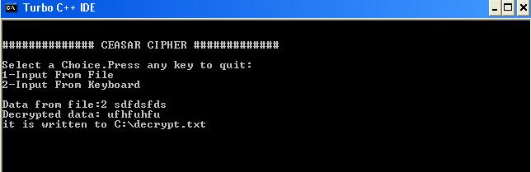
•If keyboard is choosed,results are only monitored.

